BO JIANG
Curriculum Vita (updated January 2018)
PERSONAL
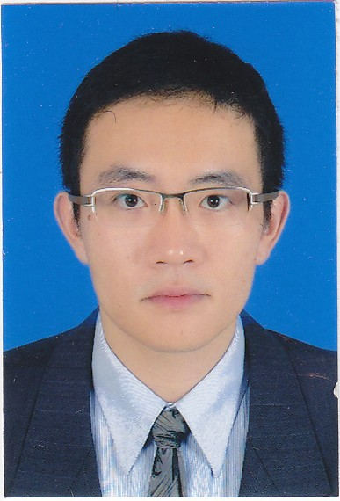
Date of Birth: August 27, 1982
Languages: Cantonese (Native), Mandarin (Fluent)
Office Address: 8400 Baltimore Avenue, Suite 250 College Park, MD 20740
Phone: (301) 405-4599
Email: bjiang@start.umd.edu
EDUCATION
August 2014
-Present Doctoral Student, Department of Criminology and Criminal Justice, University of Maryland
May 2014 University of Pennsylvania, Master of Science in Criminology
May 2011 National University of Singapore, Master of Social Sciences in Applied Economics
May 2008 National University of Singapore, Bachelor of Social Sciences in Economics (Hons)
RESEARCH INTERESTS
Quantitative Methods, Transnational Crime
RESEARCH RELATED ACTIVITIES
Journal Article
Jiang, Bo, Gary, LaFree (2017) Social control, trade openness and human trafficking. Journal of Quantitative Criminology 33(4) 887 - 913

Haiyuan Shi; Bo Jiang; Joshua Dao Wei Sim; Zhi Zhen Chum; Mun Heng Toh (2014) Factors Associated with Obesity: A Case Control Study of Young Adult Singaporean Males. Military Medicine 179(10):1158

Toh M. H., Jiang B. (2012), Singapore making progress as a brain gain nation. Samsung Economic Research Institute Quarterly 5(3) 42 - 49.

Chapters in Books
Jiang, Bo (2017). An empirical analysis of maritime terrorism using the Global Terrorism Database. In Gary LaFree and Joshua Freilich (ed.), The Handbook of the Criminology of Terrorism. John Wiley & Sons, Inc.

Toh Mun Heng and Bo Jiang (2016) The SIJORI cross-boarder region as an economic entity in 1990 and 2012, and perspectives for 2030. In Francis Hutchinson and Terence Chong (ed.), The SIJORI cross boarder region. Institute of Southeast Asian Studies.

Toh Mun Heng and Bo Jiang (2012) Brain strain and other economic issues from an aggressive open door policy. In Visiting the immigration issues in Singapore, Centre of Excellence for National Security, S. Rajaratnam School of International Studies, Nanyang Technological University.

Government Report
Co-investigator with Haiyuan Shi; Joshua Dao Wei Sim; Zhi Zhen Chum; Mun Heng Toh, “Risk factors associated with male obesity: A case control study of young adults in Singapore”, Singapore Armed Forces, October 2012.
AWARD
November 2014 American Society of Criminology, Division of International Criminology, Student Paper Competition (Doctoral Program), First Place Winner

May 2016 Outstanding Graduate Assistant Award, Graduate School, University of Maryland
PROFESSIONAL MEMBERSHIP
American Society of Criminology, American Sociological Association, American Statistical Association
PROFESSIONAL SERVICE
2014-15 Interim committee, Division of Terrorism and Biased Crime, ASC
EMPLOYMENT
September 2014 – Present National Consortium for the study of Terrorism and Response to Terrorism (START)
Graduate Research Assistant
Job Scope:
Under the mentorship of Dr. Gary LaFree, I study the causes and consequences of terrorism using quantitative methods.

June 2014 – August 2014 National Consortium for the study of Terrorism and Response to Terrorism (START)
General Associate
Job Scope:
1. Familiarization with current data collection practices and procedures and relevant documentation.
2. Careful review of media source articles to identify and codify events that satisfy the inclusion
criteria for the GTD; systematic coding of key pieces of information about these events.
3. Coding and quality control for information related to general characteristics of terrorist attacks.
4. Attending GTD meetings and contributing to training and strategic planning for data collection.

January 2012 – August 2013 National University of Singapore
Instructor
Department of Strategy and Policy
Job Scope:
1. Under the mentorship of Professor Toh Mun Heng, I taught the course “Macro and International Economics” to 312 undergraduate students. We did empirical research on the economic impacts of immigration in Singapore; wage inequality in Singapore and Malaysia; economic integration in Southeast Asia; human trafficking in Singapore and maritime piracy in Malacca Strait and South China Sea.
2. Under the mentorship of Professor Sun Bae Kim, I taught the course “Macroeconomics in the Global Economy” to 137 MBA students. We did empirical research on international trade, international finance and economic volatility.

June 2011 – December 2011 National University of Singapore
Research Associate
Centre for Maritime Studies
Job Scope:
I did quantitative and qualitative research on maritime piracy in Southeast Asia.

January 2010 – May 2011 National University of Singapore
Research Assistant
Department of Economics
Job Scope:
Using game theory, I analyzed agency problems in public private partnerships under the mentorship of Professor Anthony T. H. Chin. We published a working paper titled “Revisiting Agency Problems in Public Private Partnerships”. Please see: www.fas.nus.edu.sg/ecs/pub/wp/wp1102.pdf

January 2008 – May 2008 Land Transport Authority Singapore
Research Assistant
Job Scope:
Using prospect theory, I studied public-transport commuter behaviors under the mentorship of Professor Anthony T. H. Chin.

January 2007 – May 2007 Ministry of Defense Singapore
Research Assistant
Job Scope:
I participated in a problematic gambler behavioral study project under the mentorship of Professor Anthony T. H. Chin. I interviewed problematic gamblers, surveyed their risk preferences and tested the data using prospect theory.
GUEST LECTURER
June 2013 Beijing Institute of Technology, School of Management and Economics
June 2013 Chinese People’s Armed Police Academy, Division of Border Control
May 2013 Chinese People’s Public Security University, Department of Criminology
December 2012 Chinese People’s Public Security University, Department of Criminology
June 2012 Central University of Finance and Economics, School of Economics
PRESENTATIONS
2017 American Society of Criminology, American Statistical Association, Police Study Forum, Open University of Hong Kong
2016 American Society of Criminology
2015 American Society of Criminology
2014 American Society of Criminology
2013 Workshop on Floating Frontier organized by Institute of Southeast Asia Studies, National University of Singapore; Singapore Economic Review; American Society of Criminology
2012 Workshop on Visiting the Immigration Issue in Singapore organized by Centre of Excellence for National Security, S. Rajaratnam School of International Studies, Nanyang Technological University
2011 Singapore Economic Review

